Guidelines for packing books into boxes for commercial shipping
- Use sturdy boxes in good condition: clean, no holes, and able to fully contain the books.
- Unlike local transfers, boxes shipped commercially must be fully packed to the top. This will prevent the box being crushed by weight from above.
- Pack books in the box flat in either one or two stacks (spine to spine). See images below.
- Pack boxes to no more than 40 pounds (25 lbs max for fragile or special collections). If you haven’t filled the box when you get to 40 lbs, use a smaller box.
- Distribute the weight evenly in the box to reduce risk of dropping and ergonomic issues.
- Packing material
  - Packing material may include clean scrap paper, bubble wrap, or other cushioning material.
  - A single layer of clean, dry, flat packing material (like thin bubble wrap) is sufficient protection on the bottom and/or top.
  - Further packing material should be inserted into empty spaces to immobilize the books from the side, but not so tight that they are difficult to remove.
  - If you need to use a lot of packing material, use a smaller box.
- Oversized volumes may not lean diagonally inside the box. Place anything too big for the standard box in a larger box.
- Make sure that the box is fully closed and securely taped shut before mailing.

Books packed flat, single stack | Books packed flat, two stacks
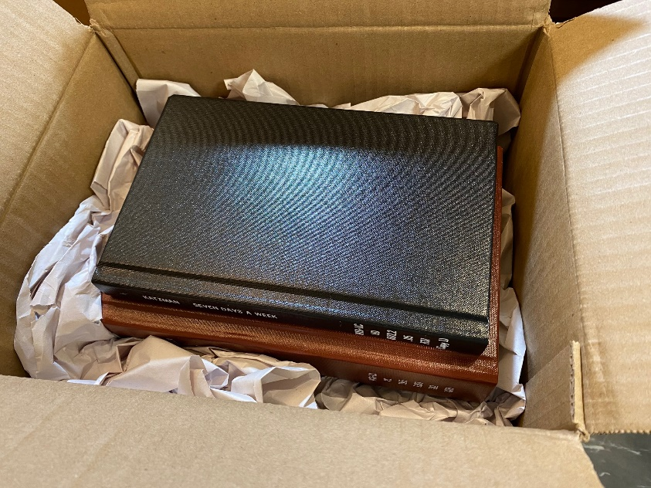 | 